Adobe Flash CS4 Professional Review
By Phil Price

Pros: Major new animation tools with 3D motion and inverse kinematics, Motion Editor, improved interface, XFL file format and easy authoring of Adobe AIR applications.
Cons: New object-based animation model is tricky at first; the 3D motion is very basic.

Adobe has really gotten their hooks into Flash since acquiring Macromedia and this release of CS4 Professional really shows it. It features a number of new features, especially a fundamental change in Flash's approach to animation. Below are the highlights.
New Animation Engine
The biggest change in Flash CS4 is its object-based animation engine. Previously, the idea was based on creating tweens between symbols that had different properties and resided on different frames along the timeline. To make any changes to the tweened frames between two key frames required making new key frames. This methodology was very straight forward, but not very flexible. Revising complex animations required tweaking lots of key frames.
The new animation engine is based on objects rather than frames. You apply tweens to objects rather than to spans of frames. You can now make changes to the in between frames without creating new key frames. It also displays an object's motion path which you can modify like any other path. This new approach is intuitive, but requires some getting used to.
Motion Editor - To adjust an object’s attributes and animation characteristics, there's a new "Motion Editor" tab. It allows you to edit objects within the timeline. It contains separate motion curves for basic X and Y motion, Z rotation, X and Y Transformation as well as for Scale, Skew, Color and Filters. There's also a path for Eases, which allows motion editing similar to an After Effects motion path. This is a major step forward for Flash. There’s several default presents, but you can save motion paths and apply them to other objects.
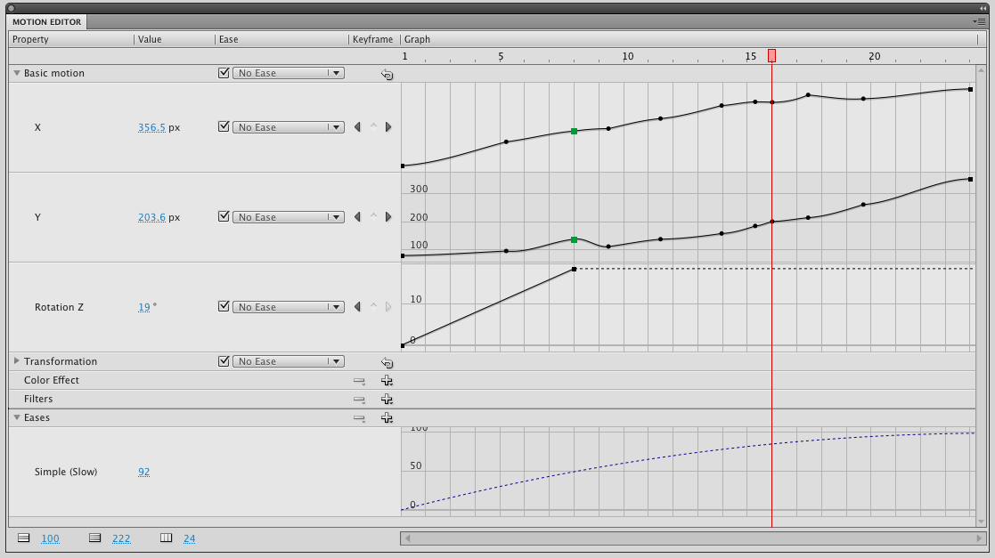
Fig. 1.1 - Motion Editor Tab
3D Transformation - Flash's animation tools have always been 2D. Sure, a good animator could fake 3D angles and motion, but now there are 3D Rotation and Translation tools.
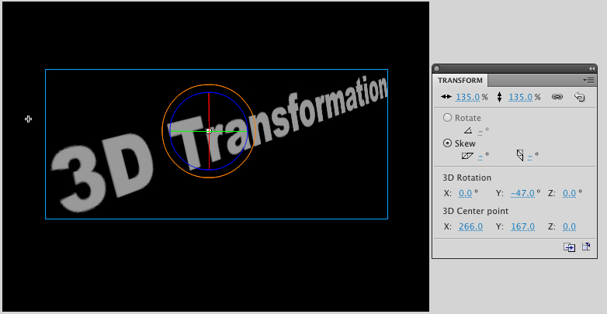
Fig. 1.2 – 3D Transformations
Inverse Kinematics – This is a fancy name for puppet animation. You can use the Bones tool on single objects or apply them to multiple objects like arms, legs, body, etc. When you move one of them the other bones react as well. In previous versions of Flash, you had to move each object separately to make them appear to act in concert with on another. Now they’re connected. You can control whether the connection just works for one parameter, or if it controls all the properties of the connected object. You can set constraints for these properties so, for example, the rotation of an arm might only rotate 90 degrees, instead of doing a complete 360.
New Interface
Flash CS4 Professional now resides in the docked workspace now common to all Adobe apps. They've moved the Timeline and Properties inspector to accommodate the new workspace layout. The Timeline now resides below the Stage and the Properties inspector is in the right sidebar. The toolbar has been moved from the left to right side. This adds some space to the Stage, but takes some getting used to. If this default layout is too awkward at first, it's possible to change and customize the entire workspace.

XFL

Importing layered files into Flash has always had its problems. The previous release was a big step forward. Photoshop and Fireworks did a pretty good job, but other apps didn’t really interface well. Adobe’s new XFL format is a new open format for Flash documents. In this release using XFL now allows importing After Effects and InDesign compositions that have been exported in the XFL format. This is the first step in Adobe’s goal of allowing documents to be passed between applications in a lossless manner.

Video Encoding – H.264

The Adobe Media Encoder now enables Flash developers to encode the H.264 format that’s popular for creating high quality, low bandwidth videos. Also, you can save an MPEG-4 rather than an FLV file, encoded as H.264, without re-encoding the video.

Adobe Air Technology
Outputting to the Adobe AIR format allows creating Flash experiences for the desktop. These can be interactive content or widgets that take Flash beyond the browser.

Conclusion

Adobe’s Flash technology has grown rapidly on the web and is becoming the platform of choice for a number of other devices as well. At January’s CES Show in Las Vegas, Adobe even announced alliances with Intel and Broadcom to bring Flash technology to high def set top boxes. With that said, Flash CS4 Professional is a major release that lays important groundwork in animation, cross platform production and video. For those already working with earlier versions of Flash, I’d rate it a strong buy.

