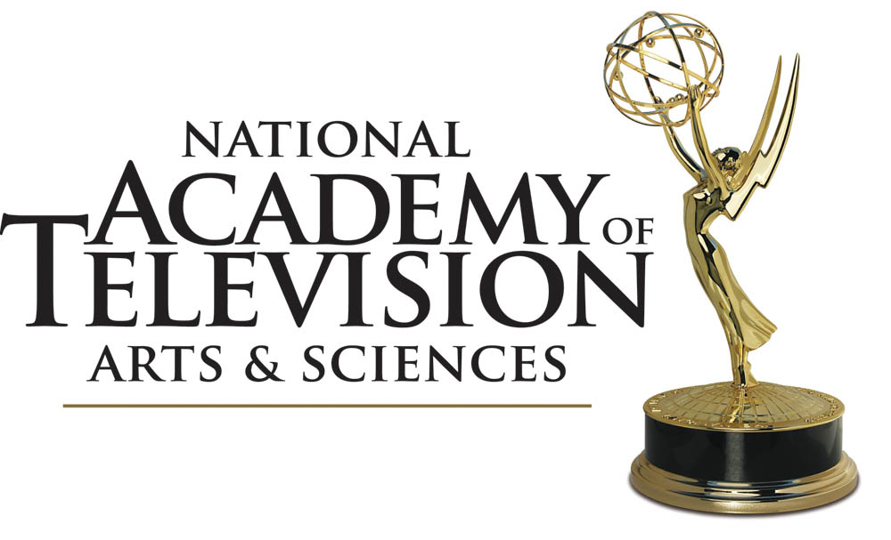

THE NATIONAL ACADEMY

OF TELEVISION ARTS & SCIENCES

ANNOUNCES WINNERS FOR

THE 40TH ANNUAL

DAYTIME ENTERTAINMENT

EMMY® AWARDS

Broadcast Live from the Beverly Hilton Hotel on the HLN Network

Los Angeles, CA – June 16, 2013 – The National Academy of Television Arts & Sciences (NATAS) tonight announced the winners of the 40th Annual Daytime Entertainment Emmy® Awards in a sold-out gala for over 1,000 attendees at the Beverly Hilton Hotel in Beverly Hills, Los Angeles.

"What an exciting night for the 40th Anniversary of the Daytime Entertainment Emmy® Awards, said Malachy Wienges, Chairman, NATAS. "Daytime television is well and prospering as witnessed by this overwhelming turnout honoring the best that television can be. Working with our production and broadcast partners, LocoDistro and the HLN Network, we've delivered an evening that truly honors the outstanding work that happens day in and day out across all the genres that make up the Daytime viewer experience."

Sam Champion, anchor, "Good Morning America," AJ Hammer, host, "HLN Showbiz Tonight, and Robin Meade, host, "HLN Morning Express, hosted this evening's festivities including a pre-show, red carpet special featuring one-on-one interviews with the night's biggest stars. Among the night's many celebrity presenters were Alex Trebek of "Jeopardy!," Kathy Griffin, "My Life on the D-List," Wayne Brady, "Let's Make A Deal," Steve Harvey, "The Steve Harvey Show," Rachael Ray, "The Rachael Ray Show," Erika Slezak, "One Life to Live," Corin Bernsen, "LA Law" and "The Young & the Restless," Bethenny Frankel, "The Bethenny Frankel Show," Dr. Drew Pinsky, "Dr. Drew," Kris Jenner, "Kris," Giada De Laurentis, "Giada at Home,"and Julie Chen, Sara Gilbert, Leah Remini, Aisha Tyler and Sheryl Underwood, "The Talk."

One of the many highlights of the evening was the presentation of the Lifetime Achievement Award to two game show icons, Monty Hall of the original "Let's Make A Deal," and legendary producer, Bob Stewart, of "The Price is Right," "Password," and "Pyramid" fame. Wayne Brady, who is the present host of Monty Hall's famous "Let's Make A Deal, presented him with the honor. The one and only Betty White, who worked with Bob Stewart and was a dear friend, presented the honor to Stewart's son, Sande, in a touching tribute. Stewart passed away last year at the age of ninety-one.

In addition, the teenage sensation, "IL VOLO," performed their hit "Mas Que Amor," in the "In Memoriam" tribute and Carrie Fisher of "Star Wars" fame gave out the "Outstanding Special Class Animation" Emmy® Award.

The Daytime Entertainment Emmy® Awards recognize outstanding achievement in all fields of daytime television production and are presented to individuals and programs broadcast from 2:00 a.m.-6:00 p.m. during the 2012 calendar year.

The 40th Annual Daytime Entertainment Emmy® Awards is a presentation of the National Academy of Television Arts & Sciences in cooperation with the Academy of Television Arts and Sciences.

A breakdown of the awards by network, as compiled by the independent accounting firm of Lutz & Carr, LLP, follows.

Off The Wall Gifts is the producer of the official Daytime Entertainment Emmy® Awards Talent Lounge and Gift Bag. Yangeroo, Inc, is the official online entry and judging portal for the National Academy of Television Arts & Sciences.

A full list of all winners in all categories can be downloaded from our website at www.emmyonline.tv.

A breakdown of Daytime Entertainment Emmy® Award winners by broadcast, cable and other entities follows:

CBS | 8 |  | NBC | 2
ABC | 3 |  | Cartoon Network | 1
Syndicated | 3 |  | Discovery Channel | 1
Food Network | 2 |  | PBS | 1

About The National Academy of Television Arts & Sciences

The National Academy of Television Arts & Sciences (NATAS) is a professional service organization dedicated to the advancement of the arts and sciences of television and the promotion of creative leadership for artistic, educational and technical achievements within the television industry. It recognizes excellence in television with the coveted Emmy® Award for News & Documentary, Sports, Daytime Entertainment, Daytime Creative Arts & Entertainment, Public & Community Service, and Technology & Engineering. Regional Emmy® Awards are given in 19 regions across the United States. Emmy® Awards given out for primetime programming are presented by our sister organization, the Academy of Television Arts & Science (ATAS). Beyond awards, NATAS has extensive educational programs including Regional Student Television and its Student Award for Excellence for outstanding journalistic work by high school students, as well as scholarships, publications, and major activities for both industry professionals and the viewing public. For more information, please visit the website at www.emmyonline.tv

About HLN

HLN is the national television network that focuses on the “must-see, must-share” stories of the day. Drawing upon the network’s deep bench of talent, including Robin Meade, Jane Velez-Mitchell, Nancy Grace, Dr. Drew Pinsky and AJ Hammer, HLN dissects and demystifies the news stories and newsmakers people are talking about.

HLNtv.com, the network’s new digital platform, is the online destination for users to go deeper into the top stories driving the conversation and generating the national buzz.

HLN is a CNN Worldwide network reaching more than 100 million households in the U.S. CNN Worldwide, a division of Turner Broadcasting System, Inc., a Time Warner Company, is the most trusted source for news and information.

LocoDistro
LocoDistro (originally launched as Locomotive Distribution, Inc.) offers boutique attention to television and film clients, combining the strongest attributes of a production company, an international distribution company, a packaging agent, and a brand identity firm. For our acquisitions partners we offer a full slate of both narrative and documentary feature films as well as scripted and unscripted TV programming. Based in New York City, our team represents a blend of creative power, audience insight and financial discipline. Our team members are not only experts in what audiences respond to, but also experts in how to reach these audiences most effectively. www.locomotivegroup.com

###

For More Information:

Website: emmyonline.tv

Paul Pillitteri, Information Officer, NATAS

ppillitteri@emmyonline.tv

The 40th Annual Daytime Entertainment Emmy® Award Winners
MULTIPLE WINNERS

The Bold and the Beautiful 4
Days of Our Lives 2
General Hospital 2
The Young and the Restless 2
The 40th Annual Daytime Entertainment Emmy® Award Winnersner

INDEX
Category Page
PROGRAMS
1. Drama Series 6
5. Culinary Program 6
6. Game Show 6
9. Morning Program 7
15. Special Class Animated Program 7
18. Talk Show- Entertainment 7
19. Talk Show- Informative 8

PERFORMERS/DRAMA
20. Lead Actress in a Drama Series 8
21. Lead Actor in a Drama Series 8
22. Supporting Actress in a Drama Series 8
23. Supporting Actor in a Drama Series 9
24. Younger Actress in a Drama Series 9
25. Younger Actor in a Drama Series 9

PERFORMERS/NON-DRAMA
26. Game Show Host 9
30. Talk Show Host 9
74. Culinary Host **NEW** 10

CRAFTS/DRAMA
34. Drama Series Directing Team 10
35. Drama Series Writing Team 10
59. Original Song 10
Outstanding Drama Series
Days of Our Lives NBC

Ken Corday, Executive Producer
Lisa de Cazotte, Greg Meng, Co-Executive Producers
Janet Drucker, Tim Stevens, Coordinating Producers
Albert Alarr, Producer

Outstanding Culinary Program

Best Thing I Ever Made Food Network

David Hoffman, Tom Rogan,
Lauren Lexton, Eddie Saenz, Executive Producers
Lisa Hockly, Co-Executive Producer
Joan Rantz, Supervising Producer
Erin McCormack, Julia Sir, Producers
Deb Jackson, Line Producer

and

Trisha's Southern Kitchen Food Network

Ellen Rakieten, Pete McPartland, Jr., Executive Producers
Meghan Hoffman Baehr, Ayesha Rokadia,
Danielle Fiorito, Gary Green, Producers
Francesco Giuseppe Pace, Line Producer

Outstanding Game Show
The Price Is Right CBS

Mike Richards, Executive Producer
Evelyn Warfel, Co-Executive Producer
Adam Sandler, Producer
Stan Blits, Sue MacIntyre, Co-Producers
Vanessa Voss, Prize Producer
Tracy Verna Soiseth, Consulting Producer
Ryan Polito, Michael Dimich, Directors

Outstanding Morning Program
CBS Sunday Morning CBS

Rand Morrison, Executive Producer
Estelle Popkin, Senior Broadcast Producer
Gavin Boyle, Jason Sacca, Amy Rosner, Senior Producers
Mary Lou Teel, Anthony Laudato, Mary Raffalli, Alan Golds,
Amiel Weisfogel, Edward Forgotson, Jon Carras, Reid Orvedahl,
Kay M. Lim, David Rothman, Amol Mhatre,
John R. D'Amelio, Peter Goodman, Douglas W. Smith, Producers
Cathy Lewis, Editorial Producer
Ramon Parkins, Entertainment Producer
Kim Skeen, Producer/Washington
David Small, Joseph Frandino, Carol A. Ross, Lauren Barnello,
Ed Givnish, Maria Nicoletti, Editors/Producers
Robin Sanders, Planning Producer
Charles Osgood, Anchor
Bill Geist, Lee Cowan, Maurice Rocca, Rita Braver, Serena Altschul,
Sharyl Attkisson, Anthony Mason, Smith Tracy,
George Pozderec, Martha Teichner, Correspondents
Addison Green, Meteorologist
Ben Stein, Nancy Giles, Faith Salie, William Flanagan, Contributing Commentators
David Edelstein, Film Critic
OUTSTANDING SPECIAL CLASS ANIMATED PROGRAM
Star Wars: The Clone Wars Cartoon Network

George Lucas, Executive Producer
Cary Silver, Producer
Athena Portillo, Line Producer
Dave Filoni, Supervising Director

OUTSTANDING TALK SHOW/ENTERTAINMENT
The Ellen DeGeneres Show SYNDICATED

Ellen DeGeneres, Mary Connelly,
Ed Glavin, Andy Lassner, Executive Producers
Derek Westervelt, Kevin A. Leman II,
Jonathan Norman, Co-Executive Producers
Melissa Geiger Schrift, Supervising Producer
Ross Williams, Coordinating Producer
Kara Hogan Leonardo, Matt Wright, Senior Producers
Lori Blackman, Alissa Cote, Jason Gelles, Claudia Gharibian, Paul Horne, Corey Palent, Liz Patrick, Lauren Pomerantz, Ryan Raddatz,
Amy Rhodes, Gil Rief, Hilary Robe, Ellen Rocamora, Beth Sherman, Bridgette Theriault, Adam Yenser, Andy Zenor, Christopher Cucci, Producers
Nicole Collins, Line Producer

OUTSTANDING TALK SHOW INFORMATIVE
The Dr. Oz Show SYNDICATED

Mindy Borman, Amy Chiaro, Executive Producers
Laurie J. Rich, Co-Executive Producer
Eric Beesemyer, Senior Supervising Producer
Dr. Mehmet Oz, Cali Alpert, Beryl Holness, Stacy Rader,
Matthew J. Strauss, Susan Wagner, Michele Wasserman,
Andrea D'Ambrosio, Supervising Producers
Andrea Chessler, Cathy Daniel, Annie DiGregorio, Kirk Fernandes, John Filimon, Lauren Bright Pacheco, Nicole Giambrone, Brooke Jacobsen, Lindsey Kotler, Allison Markowitz, Chris Molen, Margaret Pergler,
Stefanie Schwartz, Greg Tufaro, Lisa Semel, Christine Smith, Scott Starr, Laura Swalm, Ann Varney, James Avenell, Lauren Rivera, Producers
Jon Coniglio, Line Producer

OUTSTANDING LEAD ACTRESS IN A DRAMA SERIES

HEATHER TOM, as Katie Logan Spencer

The Bold and the Beautiful CBS

OUTSTANDING LEAD ACTOR IN A DRAMA SERIES

Doug Davidson, as Paul Williams

The Young and the Restless CBS
OUTSTANDING SUPPORTING ACTRESS IN A DRAMA SERIES

JULIE MARIE BERMAN, as Lulu Spencer

General Hospital ABC
OUTSTANDING SUPPORTING ACTOR IN A DRAMA SERIES

SCOTT CLIFTON, as Liam Cooper aka William Spencer III

The Bold and the Beautiful CBS

and

BILLY MILLER, as Billy Abbott

The Young and the Restless CBS

OUTSTANDING YOUNGER ACTRESS IN A DRAMA SERIES

Kristen Alderson, as Starr Manning

General Hospital ABC

OUTSTANDING YOUNGER ACTOR IN A DRAMA SERIES

CHANDLER MASSEY, as Will Horton

Days of our Lives NBC

OUTSTANDING GAME SHOW HOST

BEN BAILEY, as Host

Cash Cab Discovery Channel

OUTSTANDING TALK SHOW HOST

RICKI LAKE, as Host

The Ricki Lake Show SYNDICATED
OUTSTANDING DRAMA SERIES DIRECTING TEAM

The Bold and the Beautiful CBS

Michael Stich, Cynthia J. Popp, Deveney Kelly, David Shaughnessy, Jennifer oward, Directors
Catherine Sedwick, Clyde Kaplan, Jennifer Scott Christenson,
Steven A. Wacker, Associate Directors
Laura Yale, Douglas Hayden, Lisa Winther-Huston, Stage Managers
Lori Staffier, Production Associate

OUTSTANDING DRAMA SERIES WRITING TEAM

The Bold and the Beautiful CBS

Bradley P. Bell, Head Writer
Kay Alden, Michael Minnis, Co-Head Writers
Patrick Mulcahey, Tracey Ann Kelly, Rex M. Best, John F. Smith, Adam Dusevoir, Shannon Bradley, Michele Val Jean, Writers

OUTSTANDING ORIGINAL SONG
“GOOD AFTERNOON”
Good Afternoon America ABC

Karen Fairchild, Jimi Westbrook, Kimberly Schlapman,
Phillip Sweet, Brett Warren, Brad Warren, Alan Ives, Composers & Lyricists

OUTSTANDING CULINARY HOST

LIDIA BASTIANICH, as Host

Lidia's Italy PBS

